**NAMA: ANDI DWI SAPUTRO**

**Hackerrank username: andiads06**

1. **Soal Medium**
2. **Java Regex**

**Link:** <https://www.hackerrank.com/challenges/java-regex/problem>

Q: Write a class called MyRegex which will contain a string pattern. You need to write a regular expression and assign it to the pattern such that it can be used to validate an IP address.

Accepted Answer:

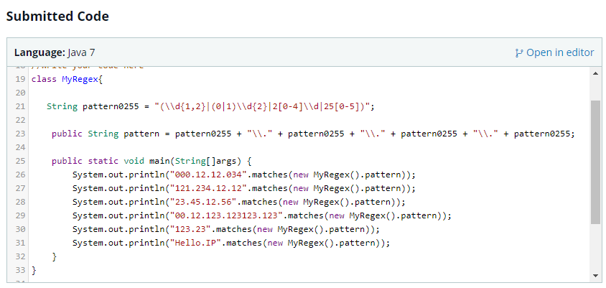

1. **Soal Easy**
2. **Java Substring**

**Link:** <https://www.hackerrank.com/challenges/java-substring/problem>

Q: Print the substring in the inclusive range from start  to end-1 .

Accepted Answer:

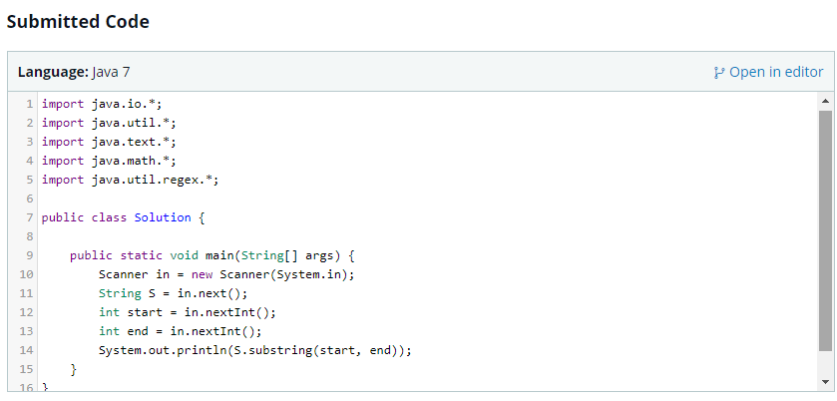

1. **Java Substring Comparison**

**Link:** <https://www.hackerrank.com/challenges/java-string-compare/problem>

Q: Return the respective lexicographically smallest and largest substrings as a single newline-separated string.

Accepted Answer:

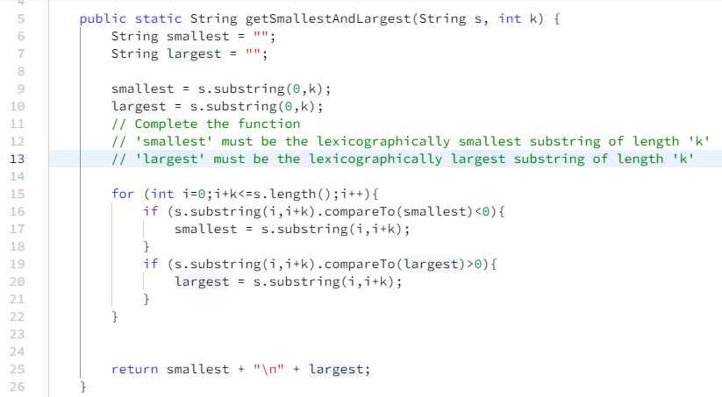

1. **Java String Reverse**

**Link:** <https://www.hackerrank.com/challenges/java-string-reverse/problem>

Q: Given a string , A print Yes if it is a palindrome, print No otherwise.

Accepted Answer:

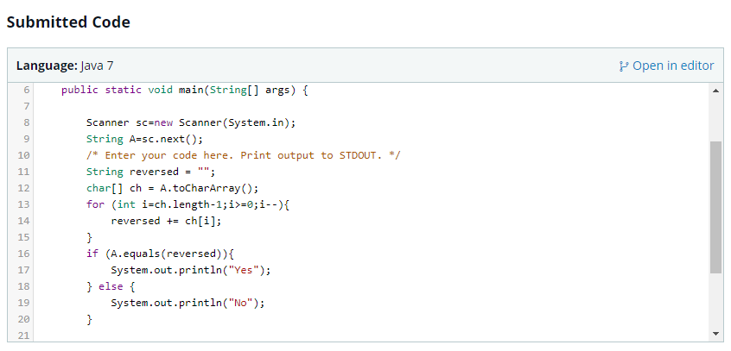

1. **Java Anagrams**

**Link:** <https://www.hackerrank.com/challenges/java-anagrams/problem>

Q: Print "Anagrams" if A  and B are case-insensitive anagrams of each other; otherwise, print "Not Anagrams" instead.

Accepted Answer:

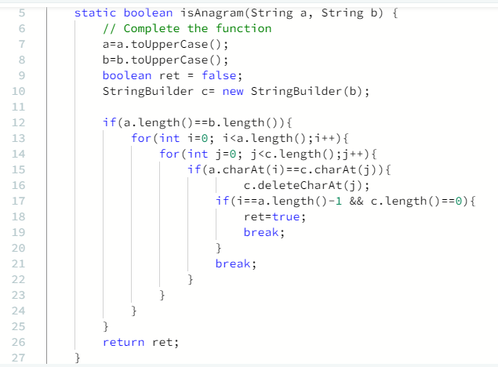

1. **Java String Tokens**

**Link:** <https://www.hackerrank.com/challenges/java-string-tokens/problem>

Q: Given a string s, matching the regular expression [A-Za-z !,?._'@]+, split the string into tokens. We define a token to be one or more consecutive English alphabetic letters. Then, print the number of tokens, followed by each token on a new line.

Accepted Answer:

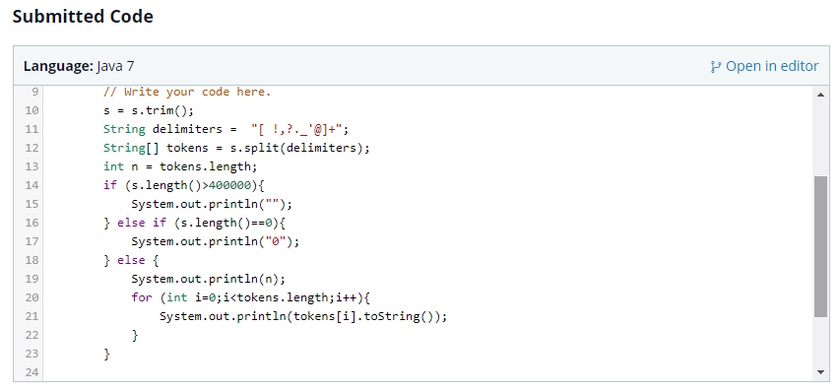

1. **Java Inheritance II**

**Link:** <https://www.hackerrank.com/challenges/java-inheritance-2/problem>

Q: Write the following code in your editor below:

1. A class named *Arithmetic* with a method named *add* that takes  2 integers as parameters and returns an integer denoting their sum.
2. A class named *Adder* that inherits from a superclass named *Arithmetic*.

**Accepted Answer:**

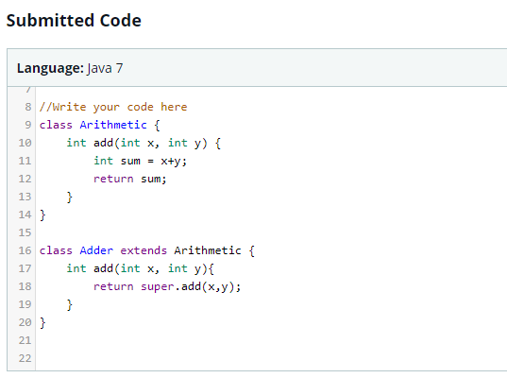

1. **Java Interface**

**Link:** <https://www.hackerrank.com/challenges/java-interface/problem>

Q: You are given an interface AdvancedArithmetic which contains a method signature int divisor_sum(int n). You need to write a class called MyCalculator which implements the interface.

Accepted Answer:

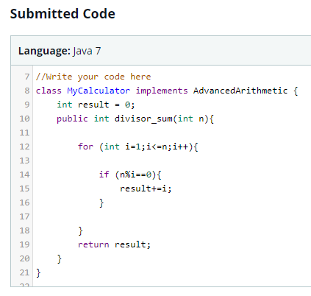

1. **Java Method Overriding 2 (Super Keyword)**

**Link:** <https://www.hackerrank.com/challenges/java-method-overriding-2-super-keyword/problem>

**Accepted Answer:**

